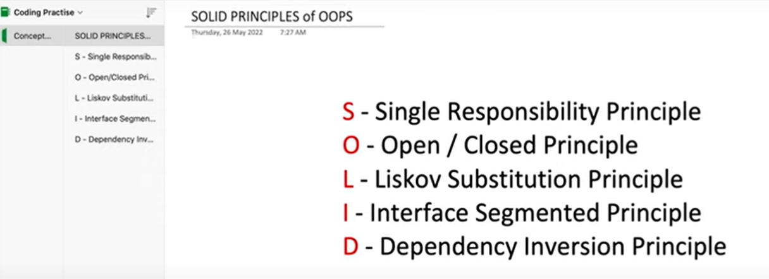

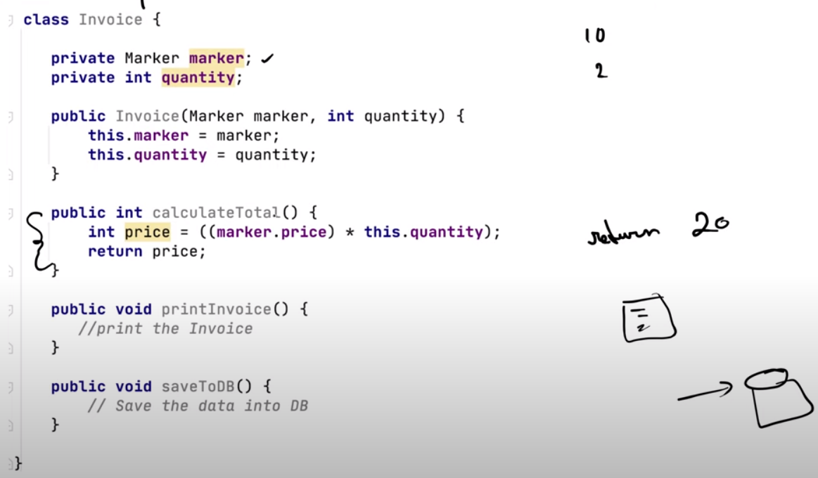

Solution: make separate class for each functionality

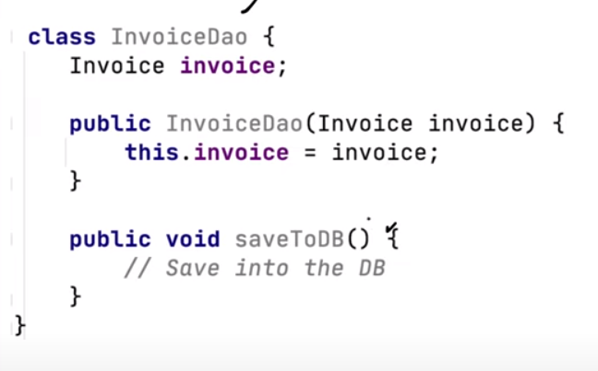

Second Principal :

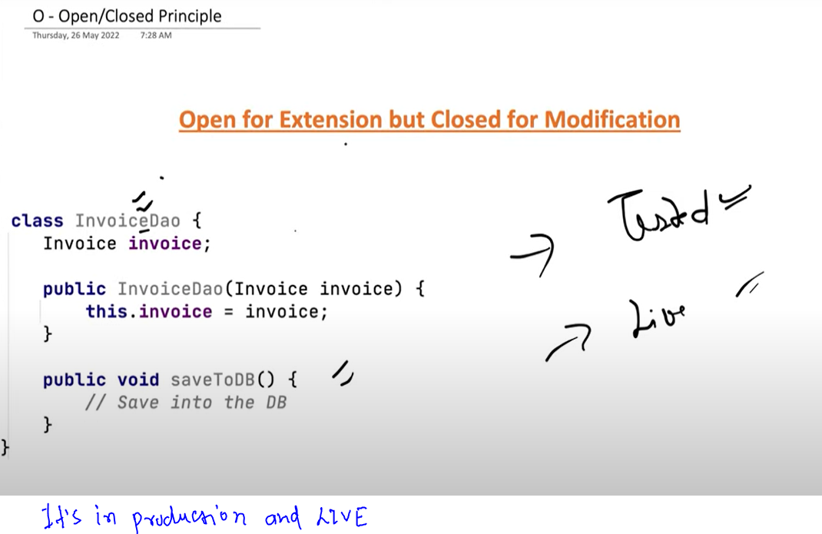

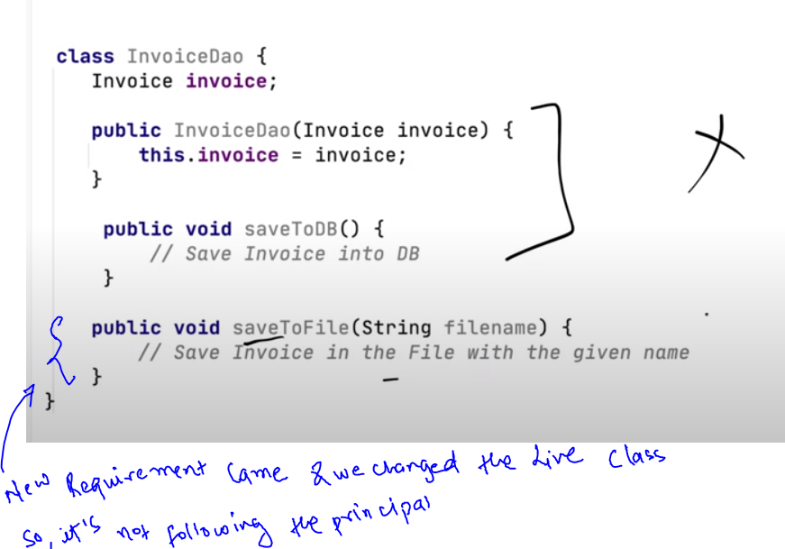

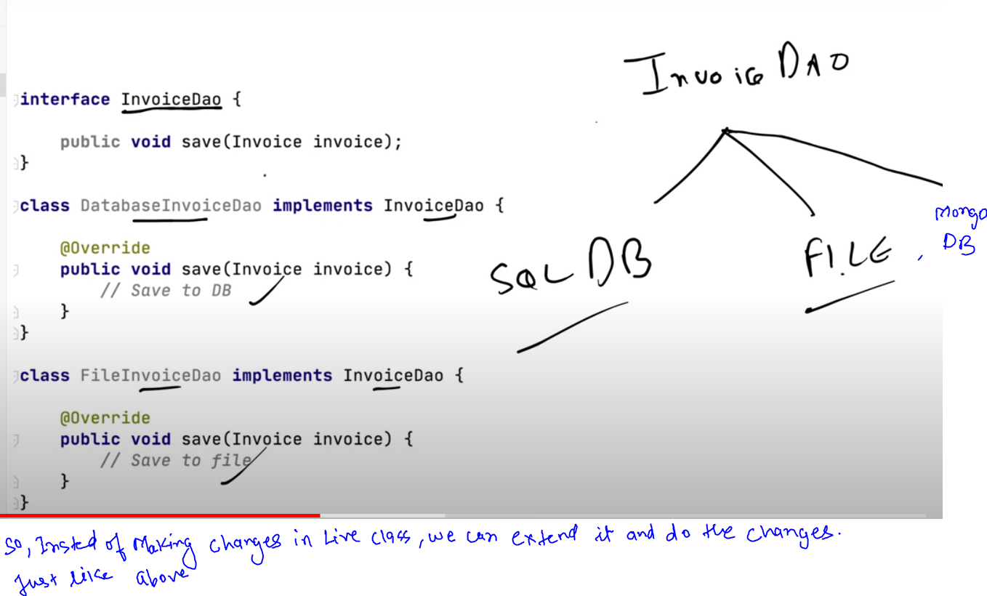

Third principal:

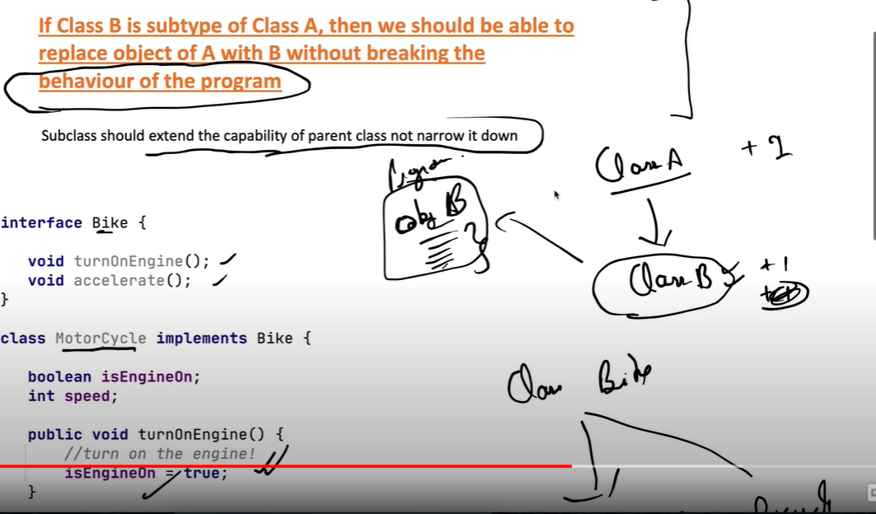

Above in second class Bicycle , we are removing one capability of parent class Bike, so it’s violating the principal.

Fourth ;

Solution

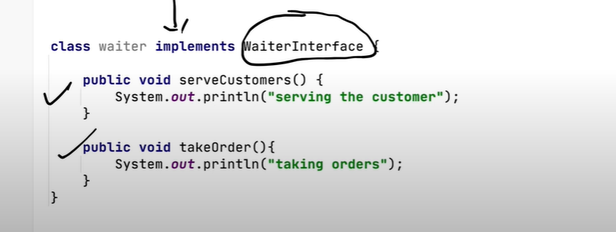

Fifth :

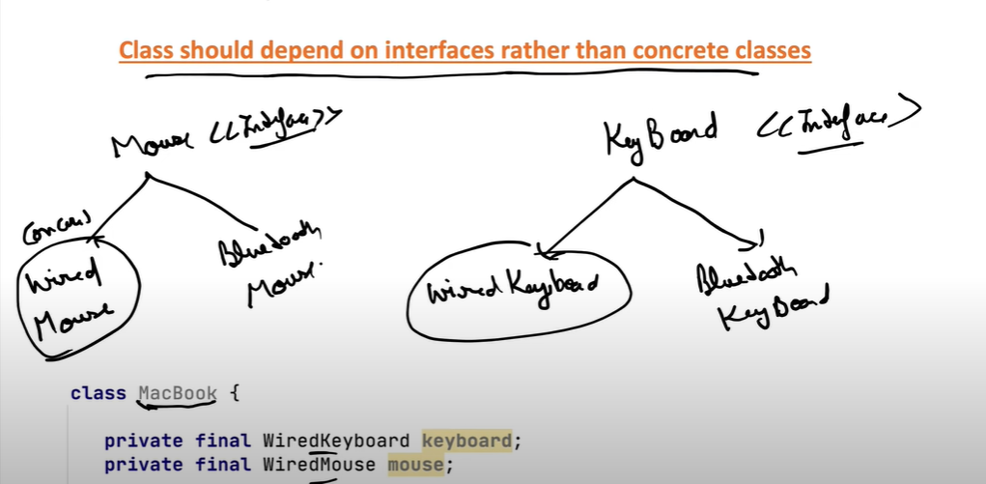

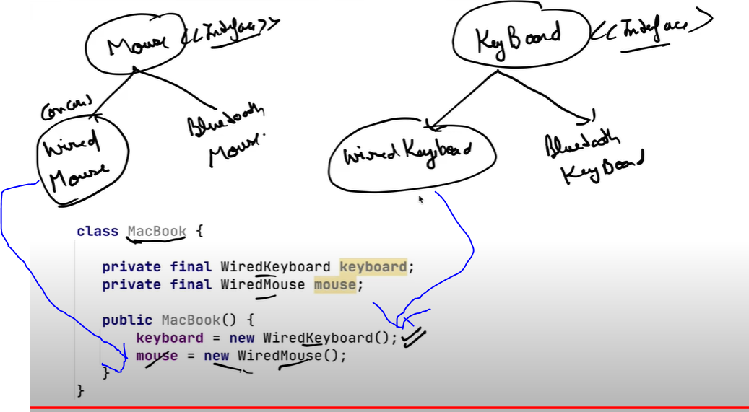

Assigning concrete class Object in above class, so no flexibility ,if requirement changes. i.e .

Object above will always be of WiredKeyboard and Wired Mouse

Solution:

In here , we can store any type of object of Keyboard and Mouse , be it Wired or Wireless, since Here Interface is holding/referencing implemented class object, so we have the flexibility to pass any kind of related object.

